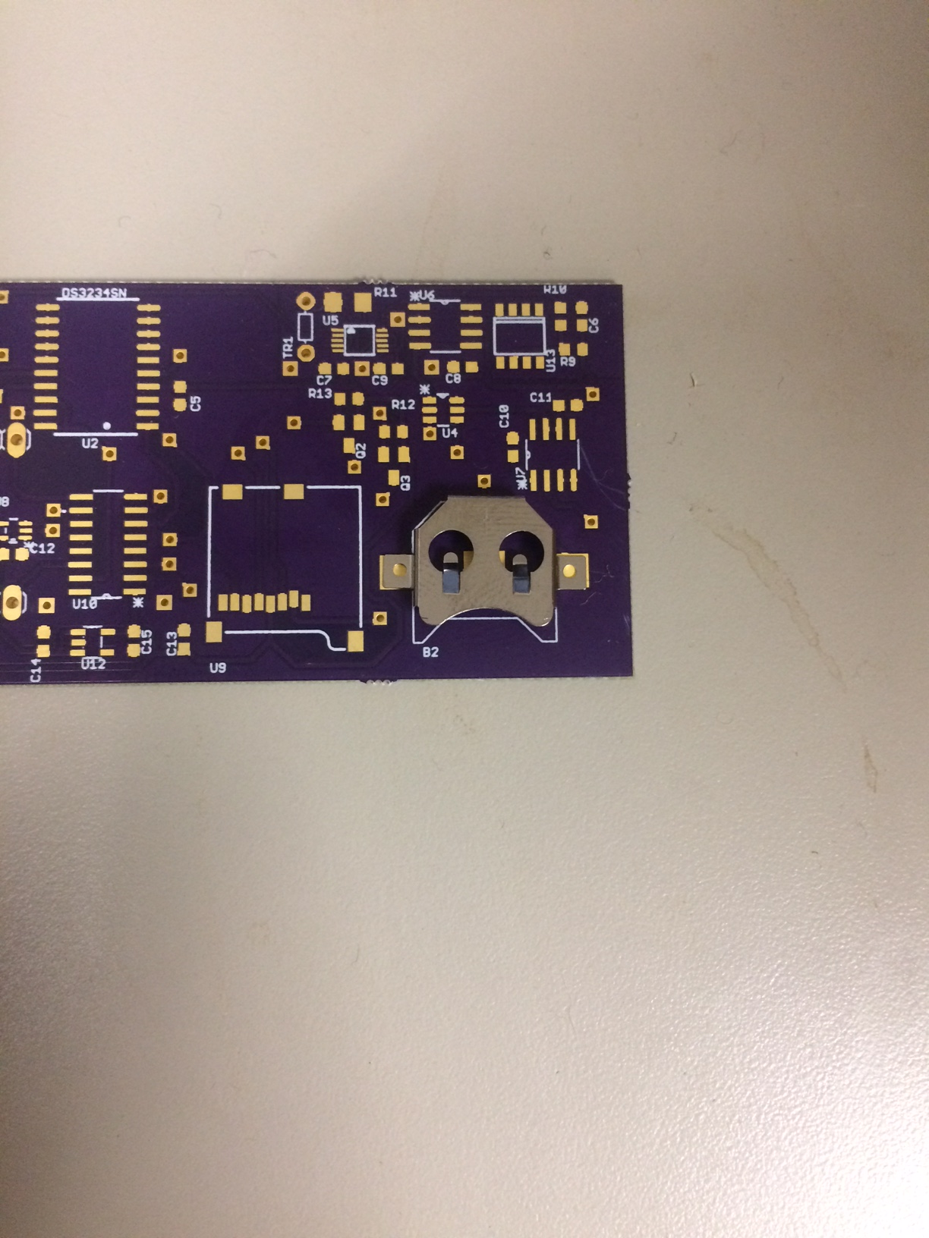

Correct Orientation of B2

\*\*Please place blob of solder on center pad before soldering the holder\*\*